Steps on How To Access Citrix Lab Manager

- To access Citrix Lab Manager Webpage, enter the address: http://172.16.89.42:8080 under the address bar as shown.
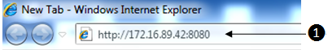

- Login using the account assign by the lecturer or TSO.

- After login, you will be in your Workspace. It should be empty and without any images.
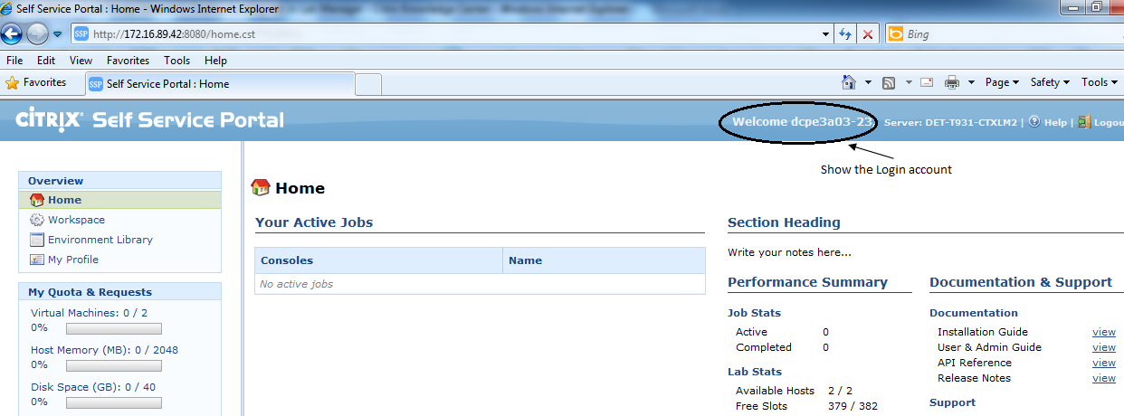

- Click "Environment Library" ❶ located on the left pane. You should display with 4 environment images for Module ET0023. Do take note of which Environment image that you are using.
Please ask if you are in doubt.
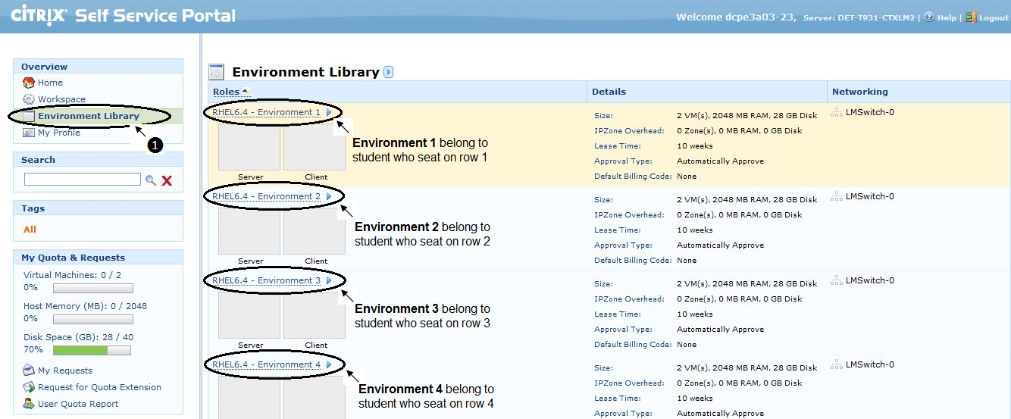

- Next you will have to copy the image to your “Workspace”. After identify on which environment image that belong to you, move your mouse cursor to the title of the image and select “Direct Copy to Workspace” as shown ❶.
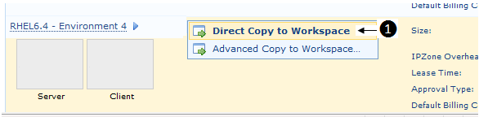

- It will now start to copy the images into your workplace. During the process, it will indicate the system is “Busy”. You will press F5 to refresh the screen.
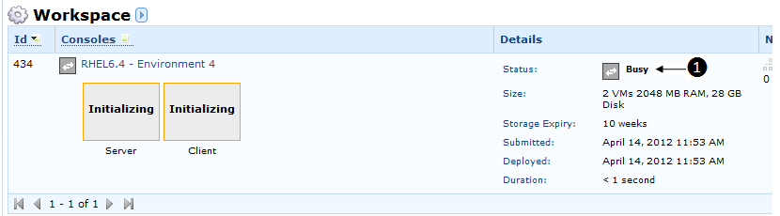

- When done. The status now is “Undeployed” ❶. Move the mouse curse to the title of the image and select “Direct Deploy” ❷to deploy those images you have just copied.
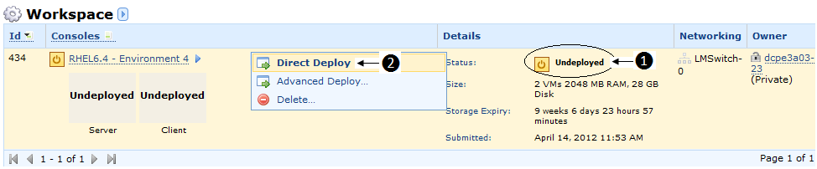

- During this process, it will indicate as “Busy”. You will press F5 to refresh the screen.
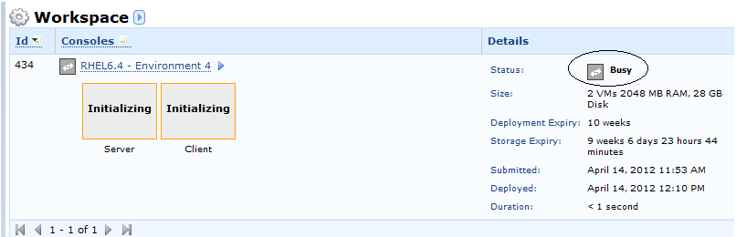

- After deployed, move the mouse curse to the image (in this example is Server) and click on the image to start the console.
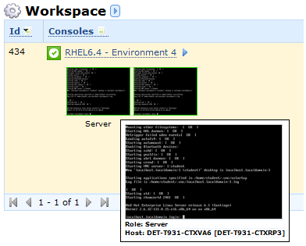

- The system will prompt you the following message. Check on the “Always trust content from this publisher” and click on “Run” to proceed.
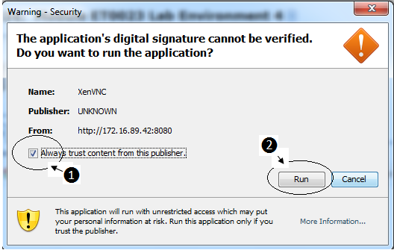

- You should be able to see now the console of the virtual machine running. 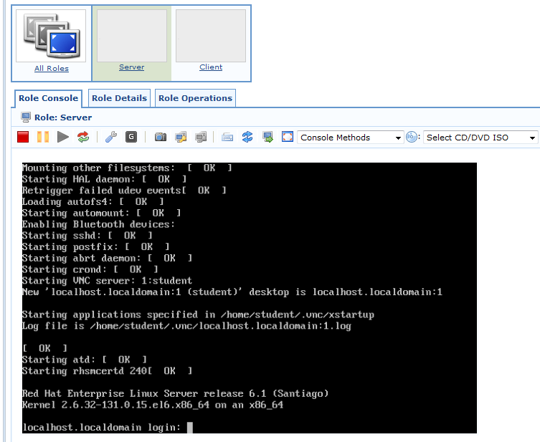

- Under the console window, logon as student, password is student.
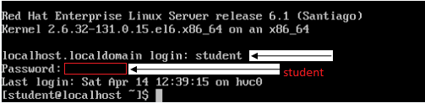
- After login to the virtual machine, issue the below command to obtain the IP address so that you can direct connect the system using VNC Viewer
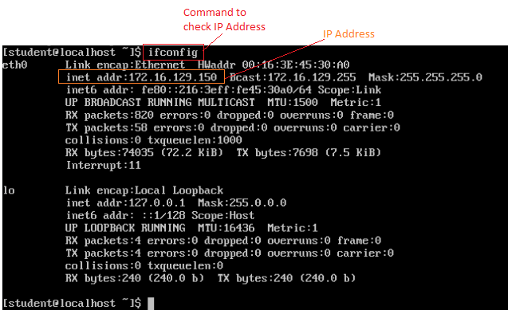

- Goto Start > Programs > UltraVNC > UltraVNC Viewer

- Type the IP address, refer to step 13, of the VNC Server and the session number in the Connection Details window and click on “Connect” button.
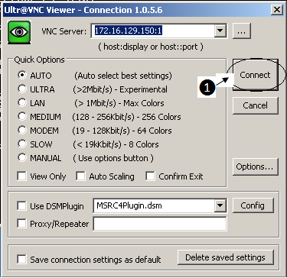
Note that all the 4 environment images are having the same session number of 1.

- Provide the password, student, for the VNC server when prompted.
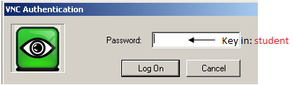

- To close the VNC session, click on the “Close Connection” icon located at the top of task bar.
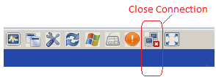

- Please shutdown you’re VMs when finished and undeloy all images under your Workspace and logout from your Citrix cloud account.

